Downtown Oronoco Gold Rush Inc.  Box 266  Oronoco, MN 55960 |  | U. S. POSTAGE PAID  Bulk Rate  CITY OF ORONOCO  PERMIT #6  ORONOCO MN
Name
Address
City State and Zip

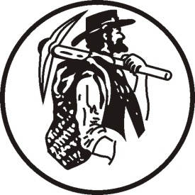

 | 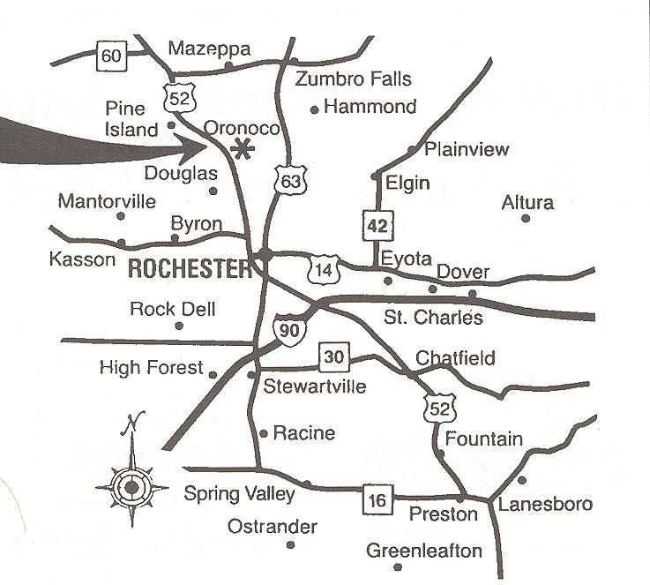 | Attention Deadline: May 15, 2020
Oronoco MN
10 miles North
of Rochester MN
Hwy 52 S Exit 64

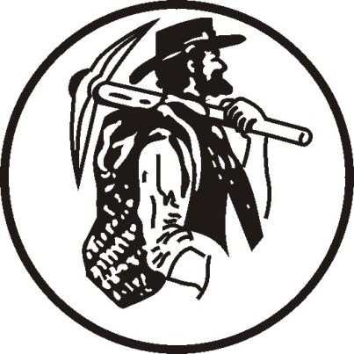
 | Proceeds go to Community Projects

August  14,15,16  2020 | Send Application/Contract to:  Downtown Oronoco Gold Rush, Inc.  Box 266  Oronoco, MN 55960  Phone: (507)367-2111  E-mail: goldrush@bevcomm.net  www.goldrushmn.com  Print carefully and make checks payable to Downtown Oronoco Gold Rush, Inc. |  |  |  |  |  | Dealer ID
Name
Company
Address
City |  |  | ST |  |  | Zip
Phone(s) |  | E-Mail
Lot(s)
WEB Site
Specialties | Define merchandise. This information for our database makes it easier if someone tries to locate you during or after the show.
Signature |  |  |  |  | State  Tax #
By signing this By signing this application/contract, I agree to abide by the rules set-up by the Downtown Oronoco Gold Rush Days, Inc. and by the City
Committee a City of Oronoco, Minnesota. Full payment must be included. We reserve the right to reject any request.

Welcome to Downtown Oronoco Gold Rush Days Inc., August 14, 15, and 16, 2020. The advertised hours of operation are Friday and Saturday, 8:00 a.m. to 6:00 p.m.; and Sunday, 8:00 a.m. to 2:00 p.m. Vendors will be allowed into the show to go to their designated lots on Thursday, August 15 at 12:00 p.m.

Review all the information and the attached map(s) for accuracy. If there are corrections, please print clearly. Sign this form and return your registration fee. You will be guaranteed the lot(s) identified in this form if your check is received by the May 16th registration deadline. Enclose a stamped self-addressed envelope if a receipt is requested.

The fee for the preceding lot(s):
1 x $100.00 = $100.00 Standard
-----------
Total = $100.00
If you are requesting additional lots, a separate check must be submitted. This check will be returned if we are unable to fulfill your request. Please reference Dealer ID on all correspondence and on your check. Include a stamped envelope for a receipt. Please note the State of Minnesota now requires that before setting up at the show, all vendors must ANNUALLY submit an ST-19 form which is attached.

Carol Olson, Event Coordinator
Downtown Oronoco Gold Rush Days Inc.
www.goldrushmn.com Facebook: Downtown Oronoco Gold Rush

